CONDITIONAL EXECUTION

1) Write a script which will take your name as an input.

2) It should check this name with your system's username.

3) If the username matches, it should greet you by displaying "Hello".

4) Else, it should display "Try again"

HINT: Your system's username is stored in a variable $USER

condition.sh

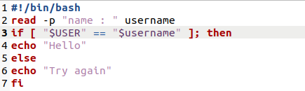

Terminal

